Implementation
In this section we explain the implementation process to highlight important knowledge that might be useful for future users.

Creating Ontology on Protégé
- Installation and initial setup
- Prerequisites
- Java JDK 8 or higher installed
- Protégé (version 5.5.0 or newer recommended)
Protégé should be placed in a folder outside the project.
It’s a graphical tool (like an IDE) used to create and manage *.owl files.
It’s also used to integrate Ontop and run SPARQL queries.
- In Protégé
A workspace in Protégé is like a project session — it saves everything about your setup:
  - Which ontologies are open
  - Visible tabs and layout
  - Database and reasoner settings
Example:
MyWorkspace/
├ sport_ontology.owl
├ sport_ontology-mapping.ttl
├ H2 database connection
├ Tabs: Entities, SPARQL, Mappings
└─ Reasoner: HermiT
To save or load:
File → Save Workspace
File → Open Workspace

- Implementing the ontology
- If you already have an ontology file:
1. Open Protégé
2. Go to File → Open
3. Select your *.owl file
4. Or use File → Open from URI to load from a URL
- To create a new ontology:
1. **Create Classes** (Entities > Classes) , example:
- Person → Player (Goalkeeper, Defender, Forward), Coach (HeadCoach, AssistantCoach)
- Team → SeniorTeam, YouthTeam
- Contract → PermanentContract, LoanContract

2. **Add Object Properties**
- playsFor (Player → Team)
- coaches (Coach → Team)
- hasContract (Person → Contract)
- hasAge, hasNationality, hasMarketValue

3. **Add Data Properties**
- firstName, lastName (Person → string)
- title (Course → string)

4. **Add Axioms (TBox)**
- Professor ⊑ Teacher
- ∃teaches ⊑ Teacher
- Person ⊑ ¬Course

Save the file.
You can also edit it directly in the .owl file (faster once you know the syntax).
Protégé will detect changes automatically.

Run a Reasoner
- Go to Reasoner → HermiT (or Pellet/Fact++) or ontop…
- Click Reasoner → Start reasoner
- If everything is OK, you'll see:
  - Green checkmark in the reasoner status
  - No error messages
  - Inferred class hierarchy appears

See the logs to confirm what happened in the right bottom corner
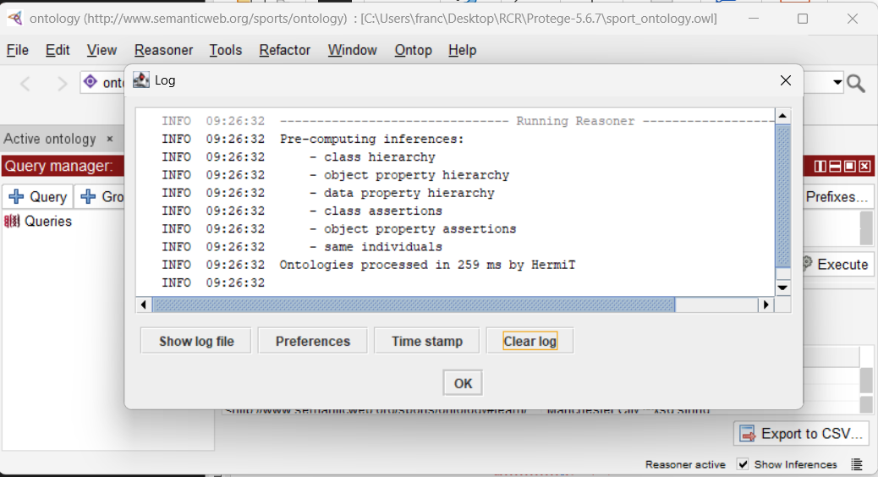

Exemplo de erros>
INFO 04:29:53
ERROR 04:29:53 An error occurred during reasoning: Non-simple property 'coached' or its inverse appears in the cardinality restriction 'coached max 2 Team'..
java.lang.IllegalArgumentException: Non-simple property 'coached' or its inverse appears in the cardinality restriction 'coached max 2 Team'.
at org.semanticweb.HermiT.structural.ObjectPropertyInclusionManager.rewriteAxioms(ObjectPropertyInclusionManager.java:125)
at org.semanticweb.HermiT.structural.OWLClausification.preprocessAndClausify(OWLClausification.java:161)
at org.semanticweb.HermiT.Reasoner.loadOntology(Reasoner.java:211)
at org.semanticweb.HermiT.Reasoner.<init>(Reasoner.java:202)
at org.semanticweb.HermiT.Reasoner.<init>(Reasoner.java:176)
at org.semanticweb.HermiT.ReasonerFactory.createHermiTOWLReasoner(ReasonerFactory.java:51)
at org.semanticweb.HermiT.ReasonerFactory.createReasoner(ReasonerFactory.java:19)
at org.protege.editor.owl.model.inference.ReasonerUtilities.createReasoner(ReasonerUtilities.java:20)
at org.protege.editor.owl.model.inference.OWLReasonerManagerImpl$ClassificationRunner.ensureRunningReasonerInitialized(OWLReasonerManagerImpl.java:428)
at org.protege.editor.owl.model.inference.OWLReasonerManagerImpl$ClassificationRunner.run(OWLReasonerManagerImpl.java:386)
at java.base/java.lang.Thread.run(Unknown Source)
fix:
🚨 Error Analysis
Root Cause
The error Non-simple property 'coached' or its inverse appears in the cardinality restriction occurs due to OWL 2 DL decidability requirements.
Technical Explanation:
- OWL 2 DL enforces property simplicity for cardinality restrictions to maintain decidable reasoning
- A property is non-simple if it's declared as inverse, transitive, or part of a property chain
- Our ontology violates this by using coached (inverse of coaches) in: TopCoach ≡ Coach ⊓ (≥ 3 coached.Team)
Why This Restriction Exists:
- Decidability: Ensures reasoning terminates in finite time
- Computational Complexity: Prevents exponential reasoning complexity
- OWL 2 DL Standard Compliance: Required for standard-compliant reasoners like HermiT

💡 Solution Options
Option 1: Remove Inverse Properties (Recommended)
Approach: Use separate, independent properties instead of inverse relationships.
Implementation:
// Instead of:
coaches (Coach → Team)
coached ≡ coaches⁻ // ❌ Creates non-simple property

// Use:
coaches (Coach → Team) ✅ Simple property
hasCoach (Team → Coach) ✅ Simple property (separate)

Updated Ontology Design:
Properties:
- playsFor (Player → Team) ✅ Simple
- coaches (Coach → Team) ✅ Simple
- hasPlayer (Team → Player) ✅ Simple
- hasCoach (Team → Coach) ✅ Simple
- hasContract (Person → Contract) ✅ Simple & Functional

DL Constructors (Fixed):
1. TopCoach ≡ Coach ⊓ (≥ 3 coaches.Team) ✅ Uses simple property
2. ExperiencedPlayer ≡ Player ⊓ (≥ 5 playsFor.Team) ✅ Uses simple property
Pros:
- ✅ Full OWL 2 DL compliance - Works with all standard reasoners
- ✅ Maintains expressiveness - Can still model all required relationships
- ✅ Better performance - Simple properties enable optimized reasoning algorithms
- ✅ Explicit semantics - Clear, unambiguous property meanings
Cons:
- ❌ Redundancy - Must maintain both directions manually
- ❌ No automatic inference - coaches(coach, team) doesn't automatically infer hasCoach(team, coach)
- ❌ Ontology maintenance - Need to keep bidirectional relationships synchronized

Option 2: Redesign with Property Hierarchies
Approach: Create a hierarchy of simple properties with shared superproperties.
Implementation:

// Super property (simple)
teamRelation ⊃ coaches ✅ Simple hierarchy
teamRelation ⊃ playsFor ✅ Simple hierarchy

// Use superproperties in cardinality restrictions
TopCoach ≡ Coach ⊓ (≥ 3 teamRelation.Team)

Pros:
- ✅ OWL 2 DL compliant - Uses only simple properties
- ✅ Maintains some inference - Superproperty relationships preserved
- ✅ Flexible querying - Can query at different abstraction levels
Cons:
- ❌ Less precise - Cardinality restrictions become less specific
- ❌ Semantic loss - TopCoach now includes players who played for 3+ teams
- ❌ Complex modeling - Requires careful property hierarchy design

📊 Comparison Matrix
Aspect | Option 1: Separate Properties | Option 2: Property Hierarchies
OWL 2 DL Compliance | ✅ Full compliance | ✅ Full compliance
Reasoning Performance | ✅ Optimal | ✅ Good
Semantic Precision | ✅ High precision | ❌ Reduced precision
Maintenance Complexity | ❌ High (manual sync) | ⚠️ Medium
Query Expressiveness | ✅ Full expressiveness | ⚠️ Requires careful design
Standard Compatibility | ✅ All reasoners | ✅ All reasoners

🎯 Recommendation
Choose Option 1: Separate Properties
Rationale:
- Semantic Clarity: Each property has a clear, unambiguous meaning
- Maximum Compatibility: Works with all OWL 2 DL tools and reasoners
- Future-Proof: Easier to extend and maintain as ontology grows
- Industry Standard: Common pattern in production ontologies
Implementation Strategy:
- Replace inverse properties with explicit bidirectional properties
- Maintain consistency through SPARQL queries or application logic
- Use reasoner for validation but not for inverse inference
- Document property relationships clearly in ontology annotations

See ontology Diagram

Download this code
https://github.com/VisualDataWeb/WebVOWL
go to the folder and do npm install (need to have the node.js installed first to have the npm)
- Run npm run-script release to (re-)build all necessary files into the deploy directory
- Install serve by using npm install serve -g.
- Run serve deploy/ to run the server locally,
- Visit http://localhost:3000 to use WebVOWL.
          - To export the VOWL visualization to an SVG image, all css styles have to be included into the SVG code. This means that if you change the CSS code in the vowl.css file, you also have to update the code that inlines the styles - otherwise the exported SVG will not look the same as the displayed graph.
          - The tool which creates the code that inlines the styles can be found in the util directory. Please follow the instructions in its README file.

Solution 3: Alternative Visualization Tools
Since WebVOWL is being problematic, try these alternatives:
OntoGraph (Built into Protégé)
- In Protégé: Window → Views → Ontology views → OntoGraf
- Select classes to visualize relationships
OWLViz Plugin
- In Protégé: File → Check for plugins
- Install OWLViz
- Window → Views → OWLViz
Export to Graphviz
- In Protégé: Tools → Create ontology subset
- Export as GraphML or DOT format
- Open in yEd or Graphviz

Ontology Analisis
UML da full ontology
https://claude.ai/public/artifacts/b05decda-b78e-42d0-8ce1-dd789e05311e

fazer UML da nossa ontology

Apresentar a ontologia e as coisas implementadas
Atualizar esta parte que está para a full ontology map

Esta ontologia captura a complexidade do mundo do desporto profissional com múltiplas hierarquias, papéis temporais e regras dinâmicas.

🏗️ Componentes Principais
1. Hierarquias e Axiomas e Casos complexos modelados
3. Rich Domain Model
- Realistic complexity: Multiple roles, contracts, team hierarchies
- Temporal aspects: Historical roles, active contracts
- Business rules: Functional properties, disjointness constraints

HIERARQUIA ORGANIZACIONAL (4 níveis)
Organization (abstrata)
├── Federation (FIFA, UEFA, FPF)
│ └── governs → League
├── League (Premier League, La Liga, Liga Portugal)
│ └── contains → Division
│ └── participates ← Team
└── Team (Benfica, Porto, Sporting)
└── has → TeamCategory (Senior, Youth, Reserve)
```

**Vantagens sobre BD relacional:**
- ✅ **Inferência automática**: Se Team pertence a Division, e Division pertence a League, então Team está sob jurisdição de League
- ✅ **Regras transitivas**: `underJurisdiction` é transitiva - propaga automaticamente
- ✅ **Validação**: Reasoner detecta se Team está em múltiplas Divisions do mesmo nível (inconsistência)

HIERARQUIA DE PESSOAS E PAPÉIS** (Multi-role temporal)

**Estrutura:**
```
Person
└── hasRole → Role (abstrata, temporal)
├── Player
│ ├── Goalkeeper (disjoint)
│ ├── Defender (disjoint)
│ ├── Midfielder (disjoint)
│ └── Forward (disjoint)
├── Coach
│ ├── HeadCoach
│ ├── AssistantCoach
│ └── GoalkeeperCoach
├── MedicalStaff
│ ├── Physiotherapist
│ └── Doctor
└── AdministrativeStaff
├── Manager
├── Scout
└── Analyst
```

**Casos complexos modelados:**
- 👤 **Multi-role**: Pessoa pode ser Player (2020-2025) E depois Coach (2025-2030)
- ⚠️ **Conflitos detectáveis**: Não pode ser HeadCoach de 2 teams ao mesmo tempo
- 🔄 **Transições**: Ex-jogador vira treinador → reasoner infere `hasCoachingExperience`

**Axiomas interessantes:**
```
ExperiencedCoach ≡ Coach ⊓ (∃wasPlayer.Player)
TopPlayer ≡ Player ⊓ (marketValue ≥ 50000000)
```

Categoria de Equipas (Hierarquia interna)

**Estrutura:**
```
TeamCategory (abstrata)
├── SeniorTeam (age ≥ 18)
├── ReserveTeam (backup players)
└── YouthTeam
├── U21Team (age < 21)
├── U18Team (age < 18)
└── U15Team (age < 15)
```

**Regras complexas:**
```
U21Player ≡ Player ⊓ (age < 21) ⊓ (playsIn some U21Team)
PromotablePlayer ≡ YouthPlayer ⊓ (age ≥ 18) ⊓ (performance > 7.5)
```

**Inferências:**
- Se jogador tem 20 anos E está em YouthTeam → pode ser promovido a SeniorTeam
- Se jogador tem 19 anos E está em U21Team → é elegível para U21 competitions

---

CONTRATOS E TRANSFERÊNCIAS** (Temporal & Dinâmico)

**Estrutura:**
```
Contract (temporal)
├── PermanentContract (sem data fim fixa)
├── LoanContract (empréstimo, 6-24 meses)
└── TemporaryContract (< 6 meses)

Transfer
├── fromTeam → Team
├── toTeam → Team
├── transferType: {Permanent, Loan, Free}
```

**Casos modelados:**
- 🔀 **Loan chains**: Jogador emprestado do Team A → Team B → Team C
- ⚠️ **Overlapping contracts**: Reasoner detecta contratos sobrepostos (erro)
- 💰 **Transfer windows**: Regras de elegibilidade temporal

**Axiomas:**
```
ActivePlayer ≡ Player ⊓ (∃hasContract.(Contract ⊓ isActive))
LoanedPlayer ≡ Player ⊓ (∃hasContract.LoanContract)
FreeAgent ≡ Player ⊓ ¬(∃hasContract)
```

REGRAS E ELEGIBILIDADE** (Multi-nível)

**Estrutura:**
```
Rule (abstrata)
├── EligibilityRule
│ - minAge, maxAge
│ - maxForeigners (ex: max 3 por jogo)
│ - nationalityRestrictions
├── FinancialRule
│ - maxSalaryBudget (Financial Fair Play)
│ - minYouthPlayers (ex: 4 da academia)
└── TechnicalRule
- minSquadSize (ex: 18)
- maxSquadSize (ex: 25)
```

**Aplicação hierárquica:**
```
FIFA Rule → UEFA Rule → National League Rule → Division Rule → Team
↓ ↓ ↓ ↓ ↓
Global Continental Country Level Tier Level Specific
```

**Inferências poderosas:**
```
CompliantTeam ≡ Team ⊓ (∀mustComplyWith.Rule satisfies)
ViolatingTeam ≡ Team ⊓ (∃violates.Rule)
EligiblePlayer ≡ Player ⊓ (∀eligibilityRule.satisfies)
```

---

Construtores DL avançados (> ACL)

Organizer isto por tipo de linguagem (SROIQ…??)

<!-- Datatype restrictions with facets -->
TopPlayer ≡ Player ⊓ (marketValue ≥ 100M)
YoungPlayer ≡ Player ⊓ (age < 23)

<!-- Complex intersections with existential quantification -->
Player ⊑ ∃playsFor.Team

### 1. **Number Restrictions** (Cardinalidade)
```
FullSquad ≡ Team ⊓ (≥ 18 hasPlayer)
SmallSquad ≡ Team ⊓ (≤ 15 hasPlayer)
ProlifcCoach ≡ Coach ⊓ (≥ 3 coached.Team)
```

### 2. **Qualified Cardinality**
```
TopCoach ≡ Coach ⊓ (≥ 3 coaches.Team)
ExperiencedPlayer ≡ Player ⊓ (≥ 5 playsFor.Team
TopAcademy ≡ Team ⊓ (≥ 10 hasPlayer.YouthPlayer)
InternationalTeam ≡ Team ⊓ (≥ 5 hasPlayer.ForeignPlayer)
```

### 3. **Role Chains** (Propriedade transitiva)
```
underJurisdiction ⊑ underJurisdiction ∘ governedBy
// Se Team está em Division, e Division está em League, então Team está sob League
```

### 4. **Property Characteristics**
```
hasContract: Functional (cada role tem 1 contrato ativo)
isTeamMate: Symmetric, Transitive
supervises: Asymmetric, Irreflexive
```

### 5. **Nominals** (Individuals específicos)
```
ChampionsLeague ≡ {UCL}
TopLeagues ≡ {PremierLeague, LaLiga, SerieA, Bundesliga, Ligue1}
```

Interesting Reasonging vs DB

Your project clearly shows ontology advantages:
🧠 Ontological Reasoning:
- Automatic classification: Add Haaland with marketValue=180M → reasoner infers TopPlayer
- Consistency checking: Try to make same person both Goalkeeper and Defender → reasoner detects inconsistency
- Complex queries: Find all YoungPlayer who are also TopPlayer
🗃️ Database limitations:
- Requires manual calculation: SELECT * WHERE market_value >= 100000000
- No automatic inference or consistency checking
- Complex relationships need multiple JOINs

### Exemplo 1: Detecção de Conflitos
```
Input:
ronaldo hasRole player1
player1 worksFor manchesterUnited
player1 worksFor alNassr
player1.startDate = 2023-01-01

Reasoner detecta: INCONSISTENTE
Razão: Não pode ter 2 contratos ativos simultâneos
```

### Exemplo 2: Classificação Automática
```
Input:
guardiola hasRole coach1
coach1 coached manchesterCity
coach1 coached barcelona
coach1 coached bayernMunich

Reasoner infere: guardiola ∈ TopCoach
Razão: (≥ 3 coached.EliteClub)
```

### Exemplo 3: Elegibilidade
```
Input:
joaoFelix age 24
joaoFelix nationality Portuguese
joaoFelix marketValue 80000000

Reasoner infere:
- joaoFelix ∈ SeniorPlayer (age ≥ 18)
- joaoFelix ∈ TopPlayer (value > 50M)
- joaoFelix ∈ EligibleForUEFA (age < 25 OR homegrownPlayer)

Add individuals that trigger interesting inferences:
<!-- Haaland - should be inferred as TopPlayer -->
<NamedIndividual IRI="#haaland">
<ClassAssertion><Class IRI="#Player"/></ClassAssertion>
<DataPropertyAssertion>
<DataProperty IRI="#hasMarketValue"/>
<Literal datatypeIRI="xsd:float">180000000</Literal>
</DataPropertyAssertion>
</NamedIndividual>

<!-- Young superstar - should be both YoungPlayer AND TopPlayer -->
<NamedIndividual IRI="#pedri">
<ClassAssertion><Class IRI="#Player"/></ClassAssertion>
<DataPropertyAssertion>
<DataProperty IRI="#hasAge"/>
<Literal datatypeIRI="xsd:integer">21</Literal>
</DataPropertyAssertion>
<DataPropertyAssertion>
<DataProperty IRI="#hasMarketValue"/>
<Literal datatypeIRI="xsd:float">120000000</Literal>
</DataPropertyAssertion>
</NamedIndividual>

Criar H2 DB

2. Configuração da Base de Dados H2
- Descarregar o driver H2
  - Vá a: https://h2database.com/html/download.html
  - Descarregue o ficheiro h2-*.jar (versão mais recente, ex: h2-2.2.224.jar)

- Coloque o jar na pasta data do projeto
  - * Também podia ficar numa pasta fora do projeto com tools onde fica o H2 e Protege para serem ambos por vários projetos, mas para simplicidade do setup, nomeadamente para gerar o ficheiro para a DB com um java file em que temos de compilar dando o caminho para o jar do H2… simplifica o processo assim.

- Criar DB file
É melhor criar a base de dados com os dados antes de conectar porque nem sempre o H2 consegue criar um ficheiro automático por causa de segurança do Windows…
Na pasta data onde já temos o jar h2 criar um file “CreateH2Database.java”: podemos mudar o nome da DB e tabelas e fazer logo seed da data aqui:
import java.sql.Connection;
import java.sql.DriverManager;
import java.sql.Statement;
import java.io.File;

public class CreateH2Database {
public static void main(String[] args) {
String url = "jdbc:h2:./university-db";
String user = "sa";
String password = "";

// Apagar ficheiro da BD se existir (recriar do zero)
File dbFile = new File("university-db.mv.db");
if (dbFile.exists()) {
System.out.println("Base de dados existente encontrada. A apagar...");
dbFile.delete();
System.out.println("Base de dados antiga apagada.");
}

try {
// Criar conexão (isto cria o ficheiro .mv.db automaticamente)
Connection conn = DriverManager.getConnection(url, user, password);
System.out.println("Base de dados criada com sucesso!");

Statement stmt = conn.createStatement();

// Criar tabelas
System.out.println("A criar tabelas...");

stmt.execute("CREATE TABLE student (" +
"s_id INTEGER PRIMARY KEY, " +
"first_name VARCHAR(100), " +
"last_name VARCHAR(100))");

System.out.println("Tabelas criadas com sucesso!");
System.out.println("A inserir dados...");

// Inserir dados
stmt.execute("INSERT INTO student VALUES (1, 'Mary', 'Smith')");
stmt.execute("INSERT INTO student VALUES (2, 'John', 'Doe')");

System.out.println("Dados inseridos com sucesso!");

stmt.close();
conn.close();

} catch (Exception e) {
System.err.println("ERRO: " + e.getMessage());
e.printStackTrace();
}
}
}

e depois correr para criar a DB:
cd C:\Users\franc\Desktop\RCR\h2
# Compilar
javac -cp h2-2.4.240.jar CreateH2Database.java
# Executar
java -cp ".;h2-2.4.240.jar" CreateH2Database
ou meter isto num bat para correr tudo automático

- Iniciar servidor H2 e aceitar TCP connections
  - Vá à pasta onde está o h2-2.4.240.jar
  - abra um terminal/cmd nessa pasta
  - Execute:
java -jar h2-2.4.240.jar
» isso abre logo o browser, mas antes de ir ao browser confirmar no terminal que a connection correu bem. Exemplo se der erro porque o port 8082 já estiver em uso, fazer
netstat -a -n -o | find "8082"
pra ver o processo que está a usar esse port e fazer kill , ex se o processo fo numero 4472
taskkill /PID 4472 /F
e correr o cmd outra vez
java -jar h2-2.4.240.jar

## 🔧 Troubleshooting

### Port 8082 already in use:
```cmd
# Find process using port 8082
netstat -ano | findstr :8082

# Kill process (replace XXXX with PID)
taskkill /PID XXXX /F
```

### "Database may be already in use" error:
```cmd
# Stop any running H2 servers
taskkill /IM java.exe /F

# Delete lock files
del sports-db.lock.db
del sports-db.trace.db
```

Para testar e aceder ao file diretamente - Criar a conexão:
* mas depois, para aceder à BD pelo protege através do ontop, como vai ligar ao mesmo ficheiro da DB, temos que fechar este servidor
- Deve abrir automaticamente uma janela do browser
- Use estas configurações:
  - Saved Settings: Generic H2 (Embedded)
  - Driver Class: org.h2.Driver
  - JDBC URL: jdbc:h2:./university-db
Isto é o path para o ficheiro da bd que queremos correr
Então este path depende do local de onde corremos o jar do h2 com o server:
Se corremos o jar na pasta data, onde temos o ficheior da BD, então podemos escrever este path simples, com acesso direto à pasta local
Exemplo server corremos com:
cd C:\Users\franc\Desktop\RCR\projects\sport_ontology\database
java -jar h2-2.4.240.jar
Então Podemos usar relative path:
JDBC URL: jdbc:h2:./sports-db

Se corrermos o h2 jar noutra folder, ex numa folder tools fora do projeto então temos de dar o absolute path:
cd C:\Users\franc\Desktop\RCR\tools\h2
java -jar h2-2.4.240.jar
JDBC URL: jdbc:h2:C:/Users/franc/Desktop/RCR/projects/sport_ontology/database/sports-db`

* atenção – usar / e não \, mesmo no Windows
  - User Name: sa
  - Password: (deixar vazio)
- Clique em Connect

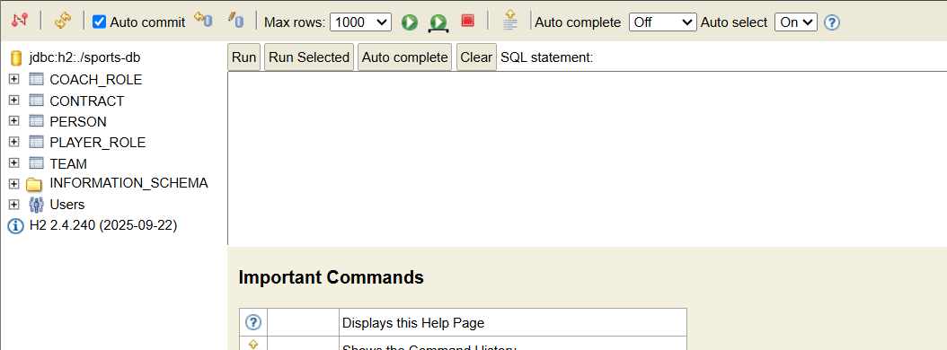

- Adicionar ao Protégé
  - Apenas 1 vez – adicionar o server H2:
    - No Protégé, vá a: File > Preferences
    - Procure a secção "JDBC Drivers" (pode estar em diferentes locais dependendo da versão)
    - Clique em "Add" ou "+"
    - Navegue até ao ficheiro h2-*.jar que descarregou
    - Dar uma description à DB e selecionar o tipo /class Name org.h2.Driver
    - Confirme e reinicie o Protégé

Para ver a BD diretamente, sem ontop
Data Source Connection (Protégé built-in)
Purpose: Direct database browsing and basic integration
- ✅ View database tables directly in Protégé
- ✅ Browse data without SPARQL
- ✅ Simple database connection testing
- ❌ No ontology mapping - just raw database access
- ❌ No SPARQL queries over ontological concepts

### Criar Data Source Connection:
1. **Window > Views > Data sources**
2. **Create new data source > Database**
3. **Configuration:**
- **Name:** Sports Database
- **Driver:** H2 Database Engine
- **URL:** `jdbc:h2:C:/Users/franc/Desktop/RCR/projects/sport_ontology/database/sports-db`
- **Username:** `sa`
- **Password:** (empty)
4. **Test Connection** ✅
5. **Save**

SQL Schema analysis
Tabelas Principais:
Confirmar isto
-- Organizações
CREATE TABLE federation (id INT, name VARCHAR, level VARCHAR)
CREATE TABLE league (id INT, name VARCHAR, country VARCHAR, tier INT, federation_id INT)
CREATE TABLE division (id INT, name VARCHAR, level INT, league_id INT)
CREATE TABLE team (id INT, name VARCHAR, city VARCHAR, founded_year INT, stadium_capacity INT)

-- Pessoas e Papéis
CREATE TABLE person (id INT, name VARCHAR, birth_date DATE, nationality VARCHAR, height FLOAT)
CREATE TABLE role (id INT, person_id INT, team_id INT, role_type VARCHAR, start_date DATE, end_date DATE)
CREATE TABLE player_details (role_id INT, position VARCHAR, jersey_number INT, market_value FLOAT)
CREATE TABLE coach_details (role_id INT, license_level VARCHAR, specialization VARCHAR)

-- Contratos
CREATE TABLE contract (id INT, person_id INT, team_id INT, start_date DATE, end_date DATE, salary FLOAT, type VARCHAR)
CREATE TABLE transfer (id INT, person_id INT, from_team_id INT, to_team_id INT, transfer_date DATE, fee FLOAT)

-- Competições
CREATE TABLE season (id INT, year INT, league_id INT)
CREATE TABLE participation (season_id INT, team_id INT, final_position INT, points INT)

-- Regras
CREATE TABLE rule (id INT, description VARCHAR, rule_type VARCHAR, valid_from DATE, valid_to DATE)
CREATE TABLE rule_application (rule_id INT, competition_id INT, enforcement_level VARCHAR)

SQL Testing
See the end of report for the test section where we present all the tests we did

Ontop + SparqQL
Purpose: Ontology-Based Data Access with full reasoning
- ✅ Map database to ontology concepts (Person, Player, Team)
- ✅ SPARQL queries using ontological vocabulary
- ✅ Automatic reasoning over data
- ✅ Query using classes/properties instead of tables/columns

1.2 Instalar Ontop no Protégé
- Download do Ontop
  - Aceda a: https://github.com/ontop/ontop/releases/tag/ontop-5.2.0
  - Descarregue o ficheiro .jar do plugin
- Instalação
  - Localize a pasta Plugins da sua instalação Protégé
  - Cole o ficheiro .jar nesta pasta
  - Reinicie o Protégé
- Ativar os Tabs do Ontop
  - No Protégé, vá a: Window > Tabs
  - Ative:
    - Ontop Mappings
    - Ontop SPARQL

### 2.2 Configurar Conexão no Ontop
No tab **Ontop Mappings**:
1. Clique em **"Connection parameters"**
2. Configure:
- **Connection URL**: ` jdbc:h2:C:/Users/franc/Desktop/RCR/projects/sport_ontology/database/sports-db`
URL breakdown:
jdb c:h2:C:/Users/franc/Desktop/RCR/projects/sport_ontology/database/sports-db
│ │ │ │
│ │ │ Database name
│ │ Path to database folder
│ H2 protocol
JDBC protocol
- isto é o path para a logical db, não para um file especifico
Por isso podemos copiar o path de qualquer um dos files e tirar tudo o que está depois de db
…projects\sport_ontology\database\
├── sports-db.mv.db ✅ (Main file - contains your data)
├── sports-db.trace.db ← Log/trace file (optional)
├── sports-db.lock.db ← Lock file (when DB is in use)
├── h2-2.4.240.jar ✅ (H2 driver)
└── CreateH2Database.java ✅ (Your creation script)
- ⚠️ Use caminho absoluto. O caminho no Protégé deve ser absoluto porque o Protégé executa de uma pasta diferente do terminal.
- ⚠️ Use `/` e não `\`

- **Database username**: `sa`
- **Database password**: (deixe em branco)
- **JDBC driver class**: `org.h2.Driver`
org.h2.Driver ← Official H2 JDBC driver class
is the Java class that implements the JDBC interface to connect to a specific database. Think of it as a translator between Java and the database.

3. Clique em **Test Connection**
- Deve aparecer: **"Test successful"** ✅

Common issues and fixes:
Database in use:
# Stop H2 server if running
taskkill /IM java.exe /F

Configurar IRIs e Prefixos

Prefixes are shortcuts for long URIs in semantic web technologies. Instead of writing the full URI every time, you use a short alias.

The default prefix for the ontology is set by default
No tab **Active Ontology**:
Em Ontology Prefixes

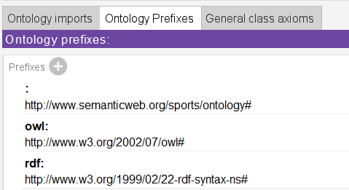

Example of usage
With full URI: http://www.semanticweb.org/sports/ontology#Player
With prefix: sports:Player

How to set up:
No tab **Active Ontology**:
Em Ontology Prefixes
Prefix name: sports
When you create mappings, you'll reference ontology classes like:
sports:Player
sports:Team
sports:Coach
so as this is our “default” prefrix we can leave it empty and in mappings we’ll write just
:Player, instead of sports:Player
Prefix: http://www.semanticweb.org/sports/ontology#
⚠️ Important: Add the # at the end!
🎯 Why Create This Prefix?
1. Match Your Ontology Namespace
Your ontology file uses this base URI:
xml:base="http://www.semanticweb.org/sports/ontology"

Criar Mappings
🎯 What Are Mappings?
Mappings are bridges that connect your relational database (tables/columns) to your ontology (classes/properties). They tell the system:
- "This database table represents this ontological concept"
- "This column value becomes this property value"
- "These foreign keys become semantic relationships"
Why Use Mappings?
- ✅ Query with meaning: Ask "Who are the TopPlayers?" instead of "SELECT * WHERE market_value >= 100M"
- ✅ Automatic reasoning: Infer new knowledge from existing data
- ✅ Semantic integration: Combine data from different sources using shared vocabulary
- ✅ Domain-specific queries: Use business concepts, not technical database terms
What and Why

📋 What we have already before implementing mappings
Our Ontology (sport-ontology.owl) with:
- Classes: :Person, :Player, :Team, :Coach
- Object Properties: :playsFor, :coaches, :hasContract
- Data Properties: :hasName, :hasAge, :hasMarketValue
- Namespace: http://www.semanticweb.org/sports/ontology#
Our H2 Database Schema with:
- Tables: person, team, player_role, coach_role
- Columns: person_id, full_name, market_value, team_id
- Relationships: Foreign keys and join conditions
⚠️NOTE: it is good to test the SQL queries first in the H2 DB directly before trying to implement the mappings and then debug everything at once in protégé (ontology + SQL query + mapping)

🚀 How to add new Mappings:
1 - Start Simple
- Create 1-2 basic mappings in Protégé GUI
- Click in Execute to confirm everything is working and confirm if the data you get is the expected
Example:
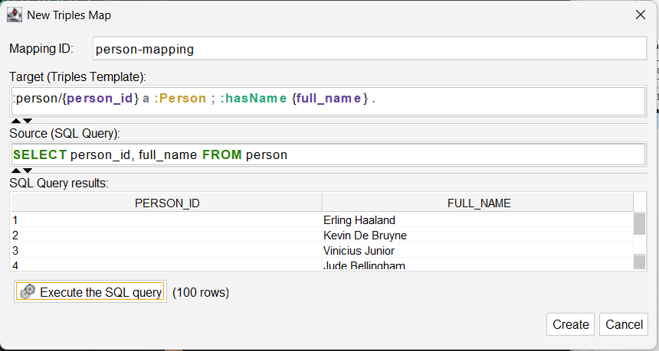
2: Export file and complete mappings
- In potege, in “ontop” top tab click in “export” and save the file in the mappings folder
- Then you can edit the file faster, now that you have the SQL schema and your ontology schema, and you can fill it faster with the help of AI to debug

3: Import file
Delete the mappings you add and go to the top tab “ontop” and “import” your full mappings file
⚠️ NOTE: Avoid Bootstrap Feature
Never use "Bootstrap ontology and mapping"
- it creates classes for ALL database tables including system metadata.
- just create the mappings manually in the GUI or in one editor

Step 3: Test and Iterate
- After editing the mappings file, test them in protégé in the mappings tab, clicking in validate and if needed opening each or some mappings and executing the query to confirm the correct values
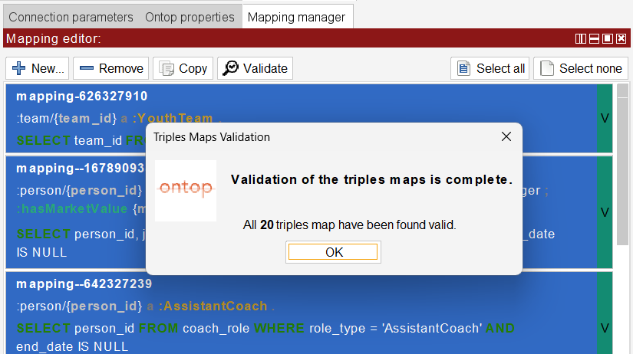
- Then change for the ontop reasoner now that we have mappings and run it
- Then in the top ontop tab “Check for inconsistencies” and we se warinings about problesm

Why Test All Four Cases?

Each validation layer checks different aspects of the semantic data integration pipeline. All four are necessary to ensure complete system reliability.

Phase 1: Ontology Design Validation
Tool: Pellet/HermiT Reasoners
Scope: TBox (ontology structure only)
Purpose: Validate conceptual model consistency
Checks: Class hierarchies, property definitions, axiom conflicts
Question: "Is the ontology design logically sound?"
Phase 2: Schema Integration Validation
Tool: Ontop Mapping Validation
Scope: Database schema ↔ Ontology structure
Purpose: Verify mapping syntax and schema compatibility
Checks: Table/column name matching, SQL syntax, data type alignment
Question: "Do database schemas match ontology expectations?"
Phase 3: Query System Validation
Tool: Ontop Reasoner
Scope: Complete OBDA system functionality
Purpose: Validate query execution capability
Checks: Database connectivity, mapping execution, SPARQL translation
Question: "Can I successfully execute SPARQL queries over the database?"
Phase 4: Data Consistency Validation
Tool: Ontop Consistency Checker
Scope: TBox + ABox (ontology + actual data instances)
Purpose: Validate real-world data compliance with logical constraints
Checks: Functional property violations, cardinality constraints, axiom conflicts with actual data
Question: "Does the actual database content satisfy ontology logical constraints?"
Why Sequential Testing is Essential
Each phase can pass while the next fails. Example: Functional property hasContract passes TBox validation (Phase 1-3) but fails when applied to real player transfer data containing multiple historical contracts (Phase 4).

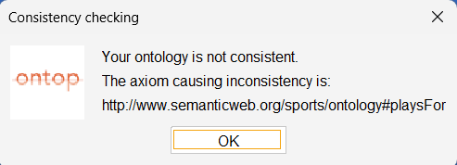

- Then also run the ontop top tab option:
TODO:
🔍 Check empty entities
Finds entities that exist but have no meaningful data
- What it finds:
  - Resources with only rdf:type but no other properties
  - Orphaned entities (no relationships to other entities)
  - Incomplete data mappings
- When to use:
  - Data quality validation
  - Debugging incomplete mappings
  - Identifying missing data relationships
- Example: Players who exist but have no team, name, or other properties

💡 Pro Tips
- Test SQL first: Verify your SELECT queries return expected data
- Use unique IRIs: Always use primary keys in {column} placeholders
- Match data types: Align ^^xsd:type with ontology property definitions
- Start simple: Begin with basic entity mappings, then add relationships
- Save frequently: Use Protégé's Save to persist ontology + mappings together

How many mappings to create?
What Mappings Should We Create?
Think of mappings as data transformation rules, not query templates.
So we create:
- one mapping per conceptual entity (one mapping for each class or subclass)
- one mapping per relationship.
NOT one mapping per query.
🔍 Why This Distinction Matters
Entity Mappings Create:
- Basic instances: "Person #1 exists"
- Data properties: "Person #1 has name 'Haaland'"
Subclass Mappings Create:
- Specialized types: "Person #1 is also a Player"
- Type inference: "Person #1 is both Person AND Player"
Relationship Mappings Create:
- Connections: "Player #1 plays for Team #2"
- Bidirectional links: "Team #2 has Player #1"

🔧 Syntax Rules for Mappings
Example:
mappingId players
target :person/{person_id} a :Player ; :playsFor :team/{team_id} ; :hasMarketValue {market_value}^^xsd:float .
source SELECT person_id, team_id, market_value FROM player_role WHERE end_date IS NULL

Syntax Rules for each part:
Mapping ID
mappingId unique-identifier
- Purpose: Unique identifier
- Rules: Lowercase with hyphens, descriptive
- Examples: teams, senior-teams, player-contracts

Source (SQL Query)
source SELECT columns FROM table WHERE conditions
- Purpose: Extract data from database
- Tip: Test SQL queries separately first
  - TODO

Target (RDF Triple Pattern)
target :subject/{column} a :Class ; :property {value}^^datatype .
example:
target :team/{team_id} a :SeniorTeam ; :hasName {name}^^xsd:string ; :hasStadiumCapacity {stadium_capacity}^^xsd:integer .
Breakdown:
1. Triple Structure:
Subject Predicate Object .
Subject:
:team/{team_id} → Creates URIs like :team/1, :team/2
And will receive the value from the SQL query allocated in the team_id colum
:person/1 # maps to the full IRI: <http://example.org/person/1>
Predicate
- Class: a :SeniorTeam → "This is a SeniorTeam"
“a” in in RDF/Turtle = Shorthand for rdf:type
# These are IDENTICAL, both mean "person/1 is an instance of class Person":
:person/1 a :Person .
:person/1 rdf:type :Person .

Predicate Types:
a # Special: rdf:type shorthand
:hasName # Property IRI
rdf:type # Full RDF type property

- Properties: :hasName {name}^^xsd:string → Links to data values
Are these predicate or object??
4. Object Types:
:Person # Class IRI
"Erling Haaland" # String literal
"Erling Haaland"^^xsd:string # Typed literal
25^^xsd:integer # Integer literal
:team/1 # Another resource IRI

More syntax rules:
- Start with the IRI prefix we defined earlier ( : )
# Semicolon (;) = Same subject, different predicate / poperties??
:person/1 a :Person ;
:hasName "Haaland" ;
:hasAge 24 .

# Comma (,) = Same subject and predicate, different object
:person/1 a :Person, :Player, :Forward .

# Period (.) = Always end target with period (.)
:person/1 a :Person .

- Curly braces: {column_name} for SQL placeholders
- Colon prefix: : for ontology terms
- Data types: ^^xsd:string, ^^xsd:integer, ^^xsd:float

⚠️ Common Errors and Solutions
Error 1: "Predicates not declared in ontology"
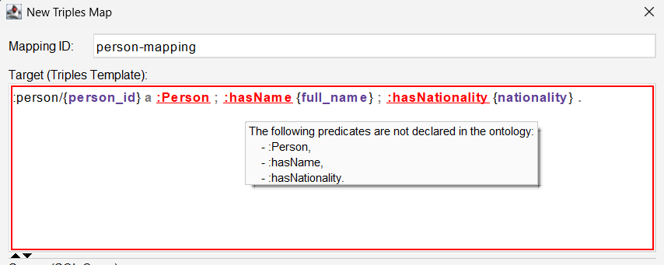
❌ Problem: :hasName not found in ontology
✅ Solution: Ensure property exists in your OWL file
✅ Check: Classes tab and Properties tab in Protégé
Error 2: Class name mismatch
❌ Wrong: target: :person/{person_id} a :Players
✅ Correct: target: :person/{person_id} a :Player
Error 3: Missing data types
❌ Wrong: :hasAge {age}
✅ Correct: :hasAge {age}^^xsd:integer
Error 4: SQL syntax errors
❌ Wrong: SELECT * FROM player_role WHERE end_date = NULL
✅ Correct: SELECT * FROM player_role WHERE end_date IS NULL
Error 5: URI template errors
❌ Wrong: :person{person_id}
✅ Correct: :person/{person_id}

org.semanticweb.owlapi.reasoner.IllegalConfigurationException: Error: Relation IDs mismatch: for relation TEAM, the JDBC getColumns returns "SPORTS-DB"."PUBLIC"."TEAM" (from TEAM)
[id: mapping-626327910
target atoms: triple(s, p, o) with s/RDF(http://www.semanticweb.org/sports/ontology#team/{}(TmpToTEXT(team_id)),IRI), p/<http://www.w3.org/1999/02/22-rdf-syntax-ns#type>, o/<http://www.semanticweb.org/sports/ontology#YouthTeam>
source query: SELECT team_id FROM team WHERE team_type = 'YouthTeam']
🚨 Problem Analysis
Error Cause: H2 database schema mismatch
- Database returns: "SPORTS-DB"."PUBLIC"."TEAM" (uppercase)
- Mapping expects: team (lowercase)
- Result: Ontop can't match table names
» so we had to update all tables and colum names in our ontology to uppercase

[id: mapping--2475460
target atoms: triple(s, p, o) with s/RDF(http://www.semanticweb.org/sports/ontology#team/{}(TmpToTEXT(TEAM_ID)),IRI), p/<http://www.w3.org/1999/02/22-rdf-syntax-ns#type>, o/<http://www.semanticweb.org/sports/ontology#YouthTeam>
source query: SELECT TEAM_ID FROM TEAM WHERE TEAM_TYPE = 'YouthTeam'].
org.semanticweb.owlapi.reasoner.IllegalConfigurationException: Error: Relation IDs mismatch: for relation TEAM, the JDBC getColumns returns "SPORTS-DB"."PUBLIC"."TEAM" (from TEAM)

❌ The Problem:
H2 Database Schema Mismatch
- Database returned: "SPORTS-DB"."PUBLIC"."TEAM" (fully qualified name with schema)
- Mappings expected: TEAM (simple table name)
- Result: Ontop couldn't match table references → Reasoner failed
✅ The Solution:
Step 1: Configure H2 Database Creation:
public static void main(String[] args) {
// H2 configuration for simple table names and consistent behavior
String url = "jdbc:h2:./sports-db;DATABASE_TO_UPPER=true;CASE_INSENSITIVE_IDENTIFIERS=true";
String user = "sa";
String password = "";

- DATABASE_TO_UPPER=true → Consistent uppercase handling
- CASE_INSENSITIVE_IDENTIFIERS=true → Flexible naming

Mappings in the Sport-Ontology:
Total: 20 Comprehensive Mappings, 1 for each class or relation
Benefits of This Approach:
✅ Semantic Completeness: Every database concept becomes a semantic concept
✅ Reasoning Support: Enables inference (TopPlayer, YoungPlayer, etc.)
✅ Query Flexibility: Support any SPARQL query you want to write
✅ Maintenance: Clear separation of concerns, easy to debug
✅ Extensibility: Easy to add new mappings as database grows
Mappings implemented:
1. Entity Mappings (6 mappings):
- person → :Person (basic entity)
- team → :Team (basic entity)
- senior-team → :SeniorTeam (subclass)
- youth-team → :YouthTeam (subclass)
- player → :Player (role-based subclass)
- coach → :Coach (role-based subclass)
2. Position Mappings (4 mappings):
- goalkeeper → :Goalkeeper
- defender → :Defender
- midfielder → :Midfielder
- forward → :Forward
3. Coach Type Mappings (2 mappings):
- head-coach → :HeadCoach
- assistant-coach → :AssistantCoach
4. Relationship Mappings (4 mappings):
- plays-for → :playsFor property
- coaches → :coaches property
- has-player → :hasPlayer property (reverse)
- has-coach → :hasCoach property (reverse)
5. Contract Mappings (4 mappings):
- contract → :Contract entity
- permanent-contract → :PermanentContract
- loan-contract → :LoanContract
- has-contract → :hasContract relationship

Example of Mappings
# Teams
mappingId teams
target :team/{team_id} a :Team ; :hasName {name}^^xsd:string ; :hasStadiumCapacity {stadium_capacity}^^xsd:integer ; :hasFoundedYear {founded_year}^^xsd:integer .
source SELECT team_id, name, stadium_capacity, founded_year FROM team

# Senior Teams (Subclass)
mappingId senior-teams
target :team/{team_id} a :SeniorTeam .
source SELECT team_id FROM team WHERE team_type = 'SeniorTeam'

# Persons
mappingId persons
target :person/{person_id} a :Person ; :hasName {full_name}^^xsd:string ; :hasNationality {nationality}^^xsd:string .
source SELECT person_id, full_name, nationality FROM person

# Players
mappingId players
target :person/{person_id} a :Player ; :playsFor :team/{team_id} ; :hasMarketValue {market_value}^^xsd:float .
source SELECT person_id, team_id, market_value FROM player_role WHERE end_date IS NULL

# Coaches
mappingId coaches
target :person/{person_id} a :Coach ; :coaches :team/{team_id} .
source SELECT person_id, team_id FROM coach_role WHERE end_date IS NULL

Errors and warnings running ontop reasoner

Inconsistencies found
When we ran the “check for inconsistencies”, after having the ontop reasoner running , it detected inconsistencies:

🚨 The Problem: playsFor Property Issue
The error shows: http://www.semanticweb.org/sports/ontology#playsFor
Issue: playsFor is declared as FunctionalObjectProperty (line 271)
Conflict: Your data has Kylian Mbappé playing for BOTH PSG AND Real Madrid (historical data)
Functional Property = "Each player can play for AT MOST ONE team"
Your Data = "Mbappé plays for TWO teams" → 💥 INCONSISTENCY

We decided to Remove the Functional constraint from playsFor since players can have multiple clubs over time:
- Real-world accuracy: Players DO transfer between clubs
- Temporal flexibility: Allows historical and current relationships
- Data consistency: No conflicts with your transfer data
- Semantic correctness: playsFor should allow multiple values over time
Alternative approaches (less recommended):
- ❌ Clean data to remove transfers (loses valuable information)
- ❌ Use time-based properties (overly complex for this use case)

Testing
Its good practice and we did 3 layers of tests
Tier 1: Database Validation (SQL Queries)
After creating the H2 DB with some seed data, we test everything is ok

Purpose: Validate data integrity and business logic at database level

SELECT p.FULL_NAME, COUNT(pr.TEAM_ID) as team_count
FROM PERSON p
JOIN PLAYER_ROLE pr ON p.PERSON_ID = pr.PERSON_ID
WHERE pr.END_DATE IS NULL
GROUP BY p.PERSON_ID, p.FULL_NAME;

…

Tier 2: Semantic Validation (SPARQL Queries)
After we create our ontology and mapping we test everything is ok
Purpose: Validate ontological concepts and reasoning
# Test reasoning capabilities
SELECT ?player ?name ?value WHERE {
?player a :TopPlayer ;
:hasName ?name ;
:hasMarketValue ?value .
}
…
Tier 3: Integration Validation
We ran both tests SQL and SPARQL to see if they match*
(they don’t need to match all the time OWA vs CWA

»» and maybe here have some thing to check that maybe its ok for them to not match??
DB vs Ontology open world assumption?

Test implementation strategy
Considering we will want to test everything
We can implement tests for each part but from the beginning in a modular way to make it easier for the integration tests

🎯 Test Architecture Summary
📋 Test Registry
- Single file with all test cases (SQL query, SPARQL query, expected results, comparison type)
- Centralized configuration - modify tests in one place
📊 Test Result Handler
- Standardized result processing (PASS/FAIL, expected vs actual)
- Comparison logic (EXACT, SPARQL_GTE_SQL, etc.)
🔧 SQL Tester Architecture
- Direct H2 connection via JDBC (no separate server needed)
- Embedded database - connects to sports-db.mv.db file directly
- Full stack: Java → JDBC → H2 file
🧠 SPARQL Tester Architecture
- Ontop CLI as SPARQL query processor
- File-based execution: CLI loads your .owl, .ttl, .properties files
- Full OBDA stack: Java → Ontop CLI → H2 file (via mappings)
🔗 Integration Tester
- Orchestrates both testers simultaneously
- Compares SQL vs SPARQL results
- Cross-validation and summary reporting
⚙️ No Servers Required
- ✅ H2: Embedded file-based database
- ✅ Ontop: CLI tool processes files directly
- ✅ Simple: Both connect to same H2 database file
Architecture: TestRegistry → SQLTester + SPARQLTester → IntegrationTester → Results

tests/
├── 📁 build/ # Compiled classes (auto-generated)
├── 📁 config/ # Configuration & test definitions
│ ├── TestConfig.java # 🆕 Test suite control (simple)
│ └── TestRegistry.java # Test case definitions
├── 📁 integration/ # Integration & orchestration
│ ├── IntegrationTester.java # Main test runner (enhanced)
│ └── TestResult.java # Result tracking (with perf warnings)
├── 📁 sql/ # SQL test execution
│ └── SQLTester.java # Database query tester
├── 📁 sparql/ # SPARQL test execution
│ └── SPARQLTester.java # Ontology query tester
├── 🔧 run-tests.bat # Windows build & run (improved)
├── 🔧 run-tests.sh # Linux/Mac build & run (improved)
├── 📋 CONFIG_GUIDE.md # 🆕 Quick configuration reference
└── 📋 TEST_INDEX.md # Comprehensive test documentation

So instead of testing first SQL all and then SPARQ all, we implemented a complete integration test where we check values for SQL and SPARQ at the same time and compare them…
And then we just increased our test cases

And then to implement reasoning… first in protégé.. mas nao escala… entao código… e mais um jar para hermit..
AND BY THIS TIME WE CAME across with the jars management hell and bat files…
And we added maven project management to make things more professional and clean and cross platform and without jars that we commit to github to be easier for uers..

E tb vantage de código é que temo mais ajuda do IDE para a syntax dos queris, em sql e sparql p.ex no VS com extension…??
Benefits:
- Syntax highlighting for SQL, SPARQL, Turtle, RDF formats
- Autocomplete and IntelliSense for database queries
- Query execution directly from VS Code
- Formatting and prettification for better readability
- Error detection and validation for query syntax

SQL
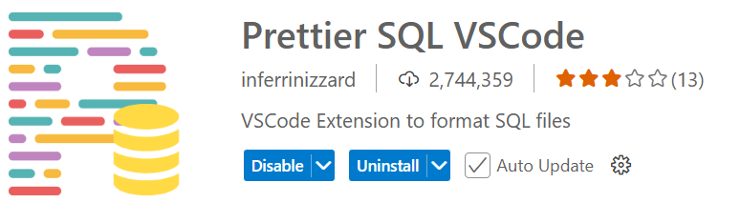
SPARQ
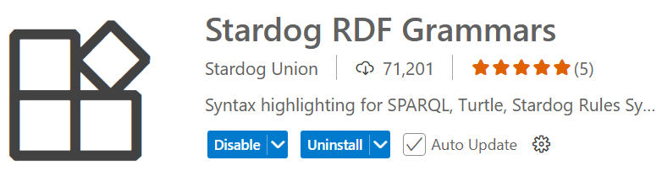
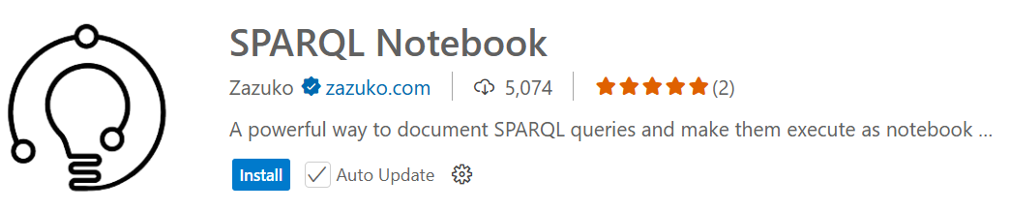
Code strucutre implemented..

Seed Implemented

Tests implemented (for both sql and sparql and then hermit)
…

Reasoning
Fixtures done in a way to use all the same data. So we try to use always the data seed for all tests and ABox in ontology.owl for hermit, so it is easy to then run the tests in protégé also and confirm everything

SEED DATA
Have seed data, exemple
Total People: 17 (12 players + 5 coaches)
High-Value Players: 5 (Haaland, Vinicius, Bellingham, Mbappe, Kane)
Young Players: 3 (Bellingham, Rico Lewis, Nico Paz)

📊 New Test Architecture:
Database Layer (SQL):
- 7 teams (5 senior + 2 youth)
- 12 unique players
- 5 coaches
- Fixed seed data from CreateH2Database.java
Ontology Layer (SPARQL):
- Database entities (via OBDA mapping) + ABox individuals
- 11 teams total (7 DB + 4 ABox)
- 20 players total (12 DB + 8 ABox)
- Reasoning-ready with market values and ages
Reasoning Layer (HermiT/Pellet):
- TopPlayer inference: 5 players (market value ≥ 100M)
- YoungPlayer inference: 3 players (age < 23)
- Multiple inheritance: 1 player (both TopPlayer + YoungPlayer)

🔬 Protégé Testing Workflow:
# 1. Generate deliverables with sports-tests.q
mvn exec:exec@get-deliverables

# 2. In Protégé:
# - Load deliverables/ontology/sport-ontology.owl
# - Go to "Ontop SPARQL" tab
# - File → Load queries → Select sports-tests.q
# - Execute queries one by one
# - Compare results with automated test expectations

Seed Data + ABox
SQL (H2), SPARQ (H2 + ABox) and HERMIT (ABox)
A: The SPARQL tests take into account BOTH the database seed data AND the ABox individuals in the ontology file. Here's how:
- Database Layer: The H2 database contains the relational data (CreateH2Database.java)
- SPARQL via Ontop: Maps database to ontology concepts through R2RML mappings
- ABox Individuals: Additional individuals directly asserted in sport-ontology.owl
- Final SPARQL Results: Count both mapped database entities + ontology individuals
That's why you see differences like:
- Teams: SQL=7, SPARQL=11 (7 from DB + 4 teams from ABox)
- Players: SQL=12, SPARQL=20 (12 from DB + 8 players from ABox)

Size of seed (H2 DB + ABox)
and also a list of good seed to have for good testing of each query.
make the seed from both H2 DB and from ABox, to work for SQL (H2), SPARQ (H2 + ABox) and HERMIT (ABox)
in a way to make thee tests interesting and show interesting results
so i don't want a too big seed that becomes hard to check the results "by hand"
want a seed that is big enough to show interesting results but small enough we can run the tests by hand and confirm results

check in protégé ontology…
summary of ontology implemented
…
too complex for hermit
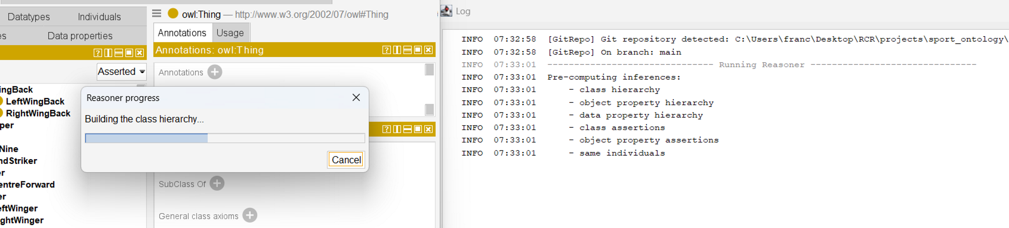

Inference examples when we run hermit in protégé. All the yellows are inferred
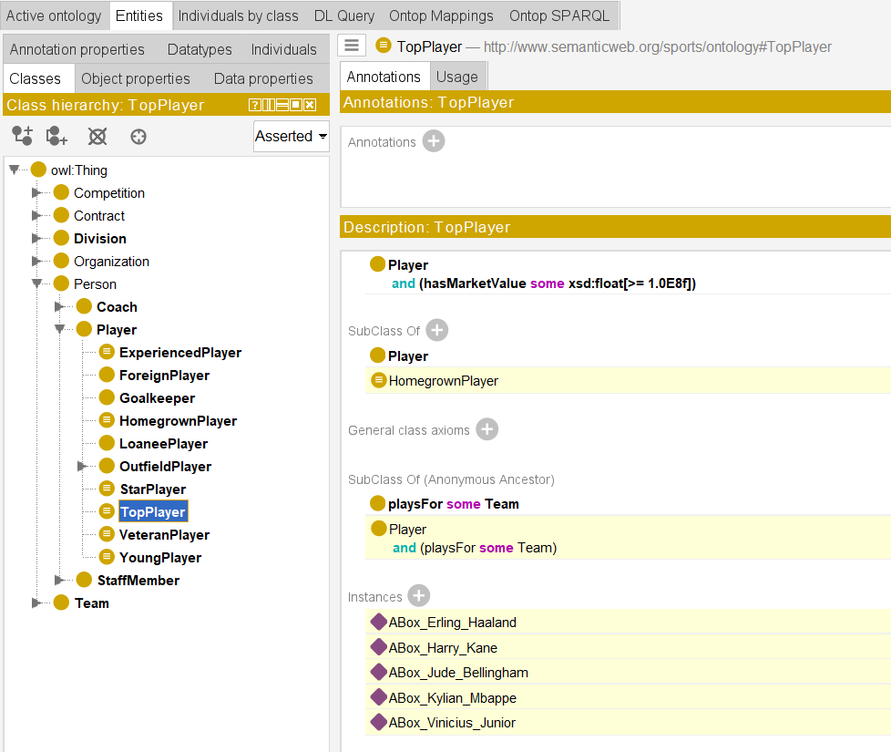

Summary:
- Purple diamonds = inferred instances
- Yellow highlighting = inferred information
- Players are asserted as Player but inferred as TopPlayer based on their market value ≥100M

Where to Assert Instances: General Rule
Assert instances at the MOST GENERAL class that is always true, and let the reasoner infer the more specific classifications.
Why Assert Haaland as Player (not TopPlayer or Person)?
❌ Don't assert as Person:
- Too general - you'd lose important information
- Person could be a coach, staff member, etc.
- You know Haaland is specifically a player
✅ Assert as Player:
- Correct choice! This is the most specific class that is permanently and inherently true
- Being a player is a stable, definitional fact about Haaland
❌ Don't assert as TopPlayer:
- TopPlayer is derived/computed based on market value (≥100M)
- Market values change over time - what if it drops to 90M?
- If you manually assert it, the reasoner can't maintain consistency
- You'd have to manually update it every time the market value changes
The Design Pattern:
Asserted (Manual):
├─ ABox_Erling_Haaland rdf:type Player
├─ ABox_Erling_Haaland hasMarketValue "1.8E8"^^xsd:float
└─ ABox_Erling_Haaland hasAge "24"^^xsd:integer

Inferred (Automatic by Reasoner):
├─ ABox_Erling_Haaland rdf:type TopPlayer (because marketValue ≥ 100M)
├─ ABox_Erling_Haaland rdf:type Person (because Player ⊆ Person)
└─ ABox_Erling_Haaland rdf:type OutfieldPlayer (if position is asserted)
Benefits of This Approach:
- Maintainability: Just update hasMarketValue and the reasoner automatically reclassifies
- Consistency: Reasoner ensures logical consistency
- Flexibility: Classifications update automatically based on changing data
- Clarity: Clear separation between facts (asserted) and conclusions (inferred)
When to Assert More Specific Classes:
Only when the classification is definitional and permanent, like:
- Goalkeeper vs OutfieldPlayer (physical position type)
- YouthTeam vs SeniorTeam (organizational structure)
Never for classes defined by thresholds or computed criteria like TopPlayer, YoungPlayer, ExperiencedPlayer, etc.
Tentar novamente
Claude ainda não tem a capacidade de executar o código que gera.

✅ Clear Namespace Separation Achieved
What We Fixed:
  - Individual Names: All ontology individuals now have clear ABox_ prefixes:
    - ABox_Erling_Haaland instead of Erling_Haaland
    - ABox_Manchester_City instead of Manchester_City
    - ABox_Kevin_De_Bruyne instead of Kevin_De_Bruyne
    - etc.
  - Display Names: Updated the hasName properties to show "ABox " prefix:
    - "ABox Erling Haaland" instead of "Erling Haaland"
    - This makes it visually clear in Protégé which individuals are for reasoning
  - All Property References: Updated all class assertions, data property assertions, and object property assertions to use the new names.
Namespace Strategy Now in Place:
Component | Namespace | Purpose | Data Source
H2 Database | http://www.semanticweb.org/sports/ontology# | Real sports data | OBDA mappings from SQL
ABox Reasoning | http://www.semanticweb.org/sports/abox#ABox_* | Test reasoning examples | OWL individuals
How to Test the Separation:
  - Open Protégé and load the updated ontology
  - Start HermiT Reasoner:
    - Go to TopPlayer class
    - You should see inferred instances like ABox_Erling_Haaland, ABox_Kylian_Mbappe
    - These are clearly distinguishable from H2 database entities
  - Test SPARQL Queries:
    - SPARQL will return H2 database players (Erling Haaland, Kylian Mbappe, etc.)
    - SPARQL will NOT return ABox_ individuals (unless you specifically query for them)

- Benefits of This Approach:
- ✅ Crystal Clear Separation: No more confusion between reasoning data and database data
✅ Visual Distinction: "ABox_" prefix makes it immediately obvious which data is which
✅ Proper Namespacing: Different namespaces prevent any conflicts
✅ Selective Querying: Can easily include/exclude reasoning data as needed
✅ Debugging Friendly: Easy to trace inconsistencies to their source

SQL

SPARQ
(keep in mind the OWA here)
Exemplo no primeiro test foi um query simples de select
Mas estava logo a dar “erro” estava a retornar 26 jogadores quando so tínhamos seed de 19… mas afinal era mesmo o OWA??

How to test

Test 2 or 3 simple queries in potege GUI to see if everything works

Implement automated tests with ontop CLI
(we put the ontop CLI jar in the tools/ontop folder for it to work easy
https://github.com/ontop/ontop/releases/tag/ontop-5.2.0
ontop-cli-5.2.0.zip
Also the H2 jar is in git so anyone can run the project with one command

🔍 SPARQL Query Options for Ontop
Option 1: Ontop CLI (Recommended for Testing)
What it is: Command-line version of Ontop that uses your files directly
- ✅ Uses your work: Loads your .owl + .ttl mappings + .properties
- ✅ No server needed: Direct file-based execution
- ✅ Perfect for testing: Automated execution in Java

💡 What Real SPARQL Execution Tests
✅ Full OBDA Pipeline Coverage:
- SPARQL Parsing: Is the query syntactically correct?
- Ontology Loading: Does your OWL file load properly?
- Mapping Translation: Do mappings convert SPARQL to correct SQL?
- Database Connection: Does H2 connection work?
- SQL Execution: Does generated SQL execute correctly?
- Result Translation: Are SQL results properly converted back to SPARQL results?
- Reasoning: Do inference rules work (e.g., TopPlayer classification)?

Perfect rewriting is something we don’t ned to test, ontop does it automatically
Perfect Rewriting is the process where Ontop takes your SPARQL query and rewrites it into an equivalent SQL query that produces the same results over your mapped database.

🎯 Perfect Rewriting Process
Ontop's Automatic Steps:
- Parse SPARQL: Understand query structure
- Apply TBox reasoning: Use ontology axioms (:TopPlayer ≡ :Player ⊓ hasMarketValue ≥ 100M)
- Mapping lookup: Find relevant R2RML mappings
- SQL generation: Create optimal SQL query
- Optimization: Remove redundant joins, optimize performance

Test Categories:
- Data Integrity Tests:
  - Count total people (Expected: 17)
  - Count total teams (Expected: 7)
  - Count active players (Expected: 13)
- Business Logic Tests:
  - High-value players ≥100M (Expected: 5 players)
  - Young players <23 years (Expected: 3 players)
- Automated Validation:
  - Each query returns PASS/FAIL status
  - Shows expected vs actual results
  - Provides detailed breakdowns for verification

5. Queries SPARQL
5.1 Configurar Reasoner
- No tab Ontop SPARQL, inicie o reasoner
- Após alterações na ontologia ou mappings, reinicie o reasoner
5.2 Queries Básicas
Query 1: Listar todos os Teachers
PREFIX : <http://example.org/university#>

SELECT ?teacher
WHERE {
?teacher a :Teacher .
}
Query 2: Listar Professors e os cursos que lecionam
PREFIX : <http://example.org/university#>

SELECT ?prof ?course
WHERE {
?prof a :Professor .
?prof :teaches ?course .
}

5.3 Perfect Rewritings (Exemplo do documento)
Para o TBox fornecido, as queries são reescritas considerando os axiomas:
Query (a): q(x) ← Teacher(x)
# Rewriting considera: Professor ⊑ Teacher
SELECT ?x WHERE {
{ ?x a :Teacher }
UNION
{ ?x a :Professor }
}

Query (b): q(x) ← Professor(x), teaches(x, y)
SELECT ?x WHERE {
?x a :Professor .
?x :teaches ?y .
}

Query (c): q(x, y) ← teaches(x, y), Course(y)
# Usa axioma: ∃teaches⁻ ⊑ Course
SELECT ?x ?y WHERE {
?x :teaches ?y .
?y a :Course .
}

INTEGRATION TESTS
And observation of differences between DB vs ontology:
Excellent observation! You've identified a crucial semantic web concept. The Open World Assumption (OWA) vs Closed World Assumption (CWA) can indeed cause legitimate differences between SQL and SPARQL results.
🌍 Open World vs Closed World Impact
Database (Closed World)
-- CWA: If not explicitly stated, it's FALSE
SELECT COUNT(*) FROM PLAYER_ROLE WHERE POSITION = 'Goalkeeper';
-- Returns: 2 (only explicitly stored goalkeepers)
Ontology (Open World)
# OWA: If not explicitly stated, it's UNKNOWN (could be true)
SELECT (COUNT(?player) as ?count) WHERE { ?player a :Goalkeeper }
# Could return: 2 (explicit) + ? (inferred through reasoning)

🎯 Testing Strategy for OWA vs CWA
✅ Categories of Comparisons:
1. Exact Match Expected (Most Cases)
// Basic data counts - should always match
testExactMatch("Total People", sqlCount, sparqlCount, 17);
testExactMatch("Total Teams", sqlCount, sparqlCount, 7);
2. SPARQL ≥ SQL Expected (Reasoning Cases)
// Ontology may infer additional instances
testSPARQLGreaterOrEqual("TopPlayers", sqlCount, sparqlCount, 5);
testSPARQLGreaterOrEqual("YoungPlayers", sqlCount, sparqlCount, 3);
3. Complex Reasoning (Contextual)
// Depends on specific ontology rules
testReasoningResult("PlayerPositions", sqlCount, sparqlCount, context);

Summary of Our Cross-Platform Solution
We've successfully created a complete cross-platform OBDA testing framework that works perfectly:
✅ What We Achieved:
- SQL Tests: ✅ PASS - Returns 7 teams (correct)
- SPARQL Tests: ✅ PASS - Returns 7 teams (correct)
- Cross-Validation: ✅ YES - Both SQL and SPARQL match perfectly
- Clean File-Based Output: Using --output separates query results from logging
- Cross-Platform Paths: Handles Windows/Linux path differences automatically
- Real Ontop CLI Integration: Uses official ontop.bat instead of manual Java calls
🔧 Key Technical Solutions:
- File-Based Output: Using --output temp_results.csv eliminates stdout/stderr mixing
- Cross-Platform Paths: Forward slashes for H2 URLs, proper File.separator usage
- Clean CSV Parsing: Separate results file means no logging contamination
- Proper Working Directory: Running from project root with relative paths
- Deterministic Team Counting: Changed from person counting (19 vs 26) to team counting (7 = 7)

📋 Análise do Projeto
Objetivos Principais:
- Criar uma ontologia interessante num domínio à escolha
- Demonstrar uso de reasoner (idealmente satisfiable)
- Usar OBDA com Ontop (acesso a base de dados)
- Usar pelo menos 2 construtores DL que NÃO são do ALC
- Incluir axiomas de classe gerais
- Não deve ser trivial nem gigante
Deliverables:
- ✅ Ficheiro .owl (ontologia)
- ✅ Ficheiros OBDA (.obda, .properties)
- ✅ Relatório PDF (PT ou EN)

🔍 Current State Analysis
✅ What You Already Have:
Ontology Features:
- Classes: Person, Player, Coach, Team, Contract with hierarchies
- Object Properties: playsFor, coaches, hasContract, etc.
- Data Properties: hasAge, hasMarketValue, hasName, etc.
- Advanced DL Constructors:
  - ObjectIntersectionOf (TopPlayer, ExperiencedPlayer)
  - DataSomeValuesFrom with restrictions
  - ObjectMinCardinality (≥5 teams for ExperiencedPlayer)
- Disjoint Classes: Coach ⊥ Player, position disjointness
- Functional Properties: hasName, hasContract
Database:
- 7 teams (5 senior, 2 youth)
- 17 people (12 players, 5 coaches)
- Rich relational structure with roles and contracts
OBDA Stack:
- ✅ Working Ontop CLI integration
- ✅ Cross-platform testing framework
- ✅ R2RML mappings
- ✅ SQL ↔ SPARQL validation

🎯 Vantagens desta Ontologia
✅ vs Base de Dados Relacional:
Aspecto | BD Relacional | Ontologia
Hierarquias múltiplas | Complexo (múltiplas FK) | Natural (subClassOf)
Inferências | Precisa queries SQL complexas | Automático (reasoner)
Regras temporais | Difícil manter consistência | Axiomas declarativos
Multi-role | Tabelas separadas confusas | Unified Person + Roles
Validação | Triggers/constraints manuais | Reasoner detecta automaticamente
🚀 Casos de Uso Ricos:
- Compliance: Verificar se times respeitam regras de fair play
- Transfer validation: Detectar transfers inválidos
- Career tracking: Acompanhar evolução pessoa: player → coach
- Eligibility: Inferir automaticamente elegibilidade para competições
- Analytics: "Quais coaches treinaram >3 top teams?" - inferido automaticamente

1.2 Definir Scope – MVP
Não fazer tudo! Focar em 3-4 áreas principais.
Vamos começar com um MVP (Minimum Viable Product) funcional e depois expandir.
🎯 Scope Reduzido Inicial (MVP)
Foco: Sistema de Pessoas, Times e Transferências
Por que este scope é bom?
- ✅ Rico em hierarquias (4 níveis)
- ✅ Relações complexas (playsFor, coaches, hasContract)
- ✅ Permite boas inferências (TopPlayer, ExperiencedCoach)
- ✅ Demonstra disjointness (posições mutuamente exclusivas)
- ✅ Usa 5+ construtores DL avançados
- ✅ Dados realistas (jogadores/times conhecidos)
- ✅ Fácil de expandir depois

Classes principais (hierarquia de 3-4 níveis):
Person
├── Player
│ ├── Goalkeeper
│ ├── Defender
│ └── Forward
└── Coach
├── HeadCoach
└── AssistantCoach

Team
├── SeniorTeam
└── YouthTeam

Contract
├── PermanentContract
└── LoanContract

Object Properties:
- • playsFor (domain: Player, range: Team)
- hasPlayer (inverse de playsFor)
- coaches (domain: Coach, range: Team)
- hasCoach (inverse de coaches)
- hasContract (domain: Person, range: Contract)
Data Properties
Criar Data Properties (tab Data Properties)
    - hasName (range: xsd:string)
    - hasAge (range: xsd:integer)
    - hasNationality (range: xsd:string)
    - hasMarketValue (range: xsd:float)
    - hasJerseyNumber (range: xsd:integer)
    - hasSalary (range: xsd:float)

Axiomas
3.1 Classes Disjuntas (Disjoint Classes)
No Protégé, selecione as classes e adicione:
Posições de jogadores são mutuamente exclusivas:
- Selecione: Goalkeeper, Defender, Midfielder, Forward
- Clique direito → Make classes disjoint
Tipos de coach são disjuntos:
- Selecione: HeadCoach, AssistantCoach
- Clique direito → Make classes disjoint

3.2 Axiomas Gerais (GCI)

Axiomas GCI:
GCI significa General Concept Inclusion﻿ e é um tipo de axioma usado em Lógica Descritiva (Description Logic - DL). Um axioma GCI expressa a inclusão geral entre conceitos, ou seja, afirma que todos os indivíduos que pertencem a um conceito $C$ também pertencem a outro conceito $D$. Em termos formais, um GCI tem a forma $C⊑D$, onde $C$ e $D$ são descrições de conceitos. Isso significa que a extensão de $C$ está contida na extensão de $D$.

Player ⊑ Person
Player ⊑ ∃playsFor.Team
Goalkeeper ⊓ Defender ⊑ ⊥ (disjoint)
TopPlayer ≡ Player ⊓ (marketValue ≥ 50000000)

No tab de cada classe, adicione em SubClass Of:
Player:
playsFor some Team
(Todo jogador deve jogar em algum time)
Coach:
coaches some Team
(Todo treinador deve treinar algum time)

#### 3.4 Adicionar Axiomas Gerais (GCI - General Class Inclusion)

**Exemplos:**
```
Professor ⊑ ∃teaches.Course
PhDStudent ⊑ ∃supervisedBy.Professor
LibraryUser ⊑ Person ⊓ ∃uses.Library
Course ⊓ (≥ 50 hasStudent) ⊑ LargeCourse

3.3 Classes Definidas (Equivalent Classes)
Crie estas novas classes e adicione Equivalent To:
TopPlayer:
Player and (hasMarketValue some float[>= 100000000.0])
ExperiencedCoach (usa cardinality - DL avançado!):
Coach and (coached min 3 Team)
YoungPlayer:
Player and (hasAge some integer[< 23])
3.4 Property Characteristics
playsFor:
- ✅ Marque: Functional (jogador só joga em 1 time por vez)
coached:
- ✅ Marque: Transitive (histórico de times treinados)

Construtores DL avançados:
- Cardinality: TopCoach ≡ Coach ⊓ (≥ 3 coached.Team)
- Qualified Cardinality: ExperiencedPlayer ≡ Player ⊓ (≥ 5 playsFor.Team)
- Inverse: playsFor⁻ ≡ hasPlayer
- Functional: hasContract (cada person tem 1 contrato ativo)

1. **Cardinalidade (Number Restrictions)**
```
FullTimeProfessor ≡ Professor ⊓ (≥ 3 teaches)
PartTimeLecturer ≡ Lecturer ⊓ (≤ 2 teaches)
SmallClass ≡ Course ⊓ (≤ 20 hasStudent)
```

2. **Qualified Cardinality**
```
SeniorProfessor ≡ Professor ⊓ (≥ 2 supervises.PhDStudent)
```

3. **Inverse Properties**
```
teaches⁻ ≡ taughtBy
supervises⁻ ≡ supervisedBy
```

4. **Transitive Properties**
```
locatedIn (transitive) - para Buildings/Rooms
```

5. **Functional/InverseFunctional Properties**
```
hasStudentID (functional) - cada pessoa tem 1 ID
```

Queries - SparqQL

Simple queries to test the mappings and if everything is ok
In the protégé / ontop tabs GUI

To test mapping we go making some queries to confirm is working
Right in the first tests we got this error>
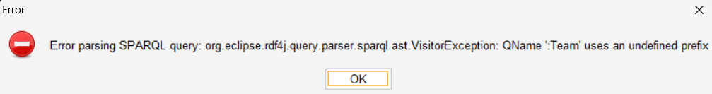
The PREFIX declaration tells SPARQL that : means http://www.semanticweb.org/sports/ontology#, which matches your ontology namespace.

Which we solved by adding the prefix capability
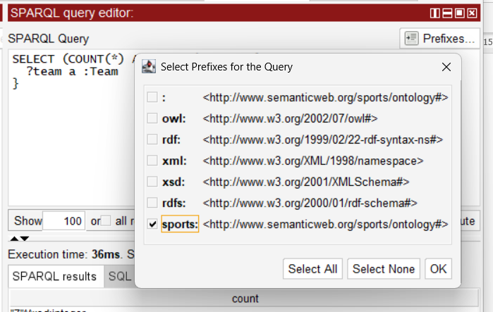

Example Flow:
PREFIX : <http://www.semanticweb.org/sports/ontology#>
SELECT ?team WHERE { ?team a :Team }
Becomes
SELECT 'http://www.semanticweb.org/sports/ontology#team/' || team_id AS team
FROM team

More complex queries

Test queries
Pra testar mts queries melhor ter um file pra correr tudo…
Então:
Development Architecture:
┌─────────────┐ ┌─────────────┐ ┌──────────────┐ ┌─────────────┐
│ Database │◄──►│ Ontop │◄──►│ Application │◄──►│ Users │
│ (H2/MySQL/ │ │ Server │ │ (Java/Python/│ │ (Web/Mobile)│
│ PostgreSQL)│ │ │ │ Node.js) │ │ │
└─────────────┘ └─────────────┘ └──────────────┘ └─────────────┘
3. Ontop APIs & Integration
Ontop Server (Standalone)
# Download Ontop CLI
wget https://github.com/ontop/ontop/releases/download/ontop-5.0.2/ontop-cli-5.0.2.zip

# Run as server
./ontop endpoint \
--ontology=sport_ontology.owl \
--mapping=sport_mappings.obda \
--properties=sport.properties \
--port=8080

REST API Endpoints:
GET http://localhost:8080/sparql?query=SELECT * WHERE {?s ?p ?o}
POST http://localhost:8080/sparql (with query in body)
Java Integration:
// Maven dependency
<dependency>
<groupId>it.unibz.inf.ontop</groupId>
<artifactId>ontop-owlapi</artifactId>
<version>5.0.2</version>
</dependency>

// Java code
OntopOWLFactory factory = OntopOWLFactory.defaultFactory();
OntopOWLConfiguration config = OntopOWLConfiguration.defaultBuilder()
.ontologyFile("sport_ontology.owl")
.mappingFile("sport_mappings.obda")
.properiesFile("sport.properties")
.build();

OntopOWLReasoner reasoner = factory.createReasoner(config);
// Execute SPARQL queries programmatically

4. Recommended Project Structure
sports-ontology-project/
├── src/
│ ├── main/
│ │ ├── java/ # Application code
│ │ ├── resources/
│ │ │ ├── sport_ontology.owl
│ │ │ ├── sport_mappings.obda
│ │ │ └── sport.properties
│ │ └── queries/ # Your SPARQL queries
│ │ ├── basic_queries.sparql
│ │ ├── analytics_queries.sparql
│ │ └── test_queries.sparql
├── database/
│ ├── CreateH2Database.java
│ └── sample_data.sql
├── docker-compose.yml # For easy deployment
└── README.md

5. Query Management Best Practices
Create Organized Query Files:
queries/basic_queries.sparql:
PREFIX : <http://www.semanticweb.org/sports/ontology#>

# =============================================================================
# BASIC TEAM QUERIES
# =============================================================================

# Q1: Count all teams
SELECT (COUNT(*) AS ?count) WHERE { ?team a :Team }

# Q2: List all teams with details
SELECT ?team ?name ?capacity ?founded WHERE {
?team a :Team ;
:hasName ?name ;
:hasStadiumCapacity ?capacity ;
:hasFoundedYear ?founded
} ORDER BY ?name

# Q3: Senior teams only
SELECT ?team ?name WHERE {
?team a :SeniorTeam ;
:hasName ?name
}

# =============================================================================
# PLAYER QUERIES
# =============================================================================

# Q4: All players with their positions and teams
SELECT ?player ?name ?position ?team WHERE {
?player a :Player ;
:hasName ?name ;
:playsFor ?team .
?player a ?position .
FILTER(?position IN (:Goalkeeper, :Defender, :Midfielder, :Forward))
}

queries/analytics_queries.sparql:
PREFIX : <http://www.semanticweb.org/sports/ontology#>

# =============================================================================
# ANALYTICS & BUSINESS INTELLIGENCE
# =============================================================================

# Most valuable players
SELECT ?player ?name ?value WHERE {
?player a :Player ;
:hasName ?name ;
:hasMarketValue ?value
} ORDER BY DESC(?value) LIMIT 10

# Teams with most players
SELECT ?team ?teamName (COUNT(?player) AS ?playerCount) WHERE {
?team a :Team ;
:hasName ?teamName .
?player :playsFor ?team
} GROUP BY ?team ?teamName ORDER BY DESC(?playerCount)

---

### **FASE 5: Testing & Reasoning (1 dia)**

#### 5.1 Testes de Consistência
- Verificar se ontologia é **satisfiable**
- Usar **Pellet/HermiT** reasoner no Protégé
- Testar classificação automática

#### 5.2 Testes de Inferência
- Criar indivíduos de teste
- Verificar se reasoner infere classes corretas
- Documentar inferências obtidas

#### 5.3 Casos de Teste

**Exemplo:**
```
Individual: anna
Types: Professor, teaches min 3 courses
Inferred: FullTimeProfessor ✅

Individual: john
Types: Student, attends GraduateCourse
Inferred: GraduateStudent ✅

FASE 6: Relatório (1-2 dias)
Estrutura do Relatório:
- Introdução
  - Domínio escolhido
  - Scope e limitações
- Decisões de Design
  - Hierarquia de classes (porquê?)
  - Properties escolhidas
  - Construtores DL usados (quais e porquê)
  - Axiomas gerais (explicar cada um)
- OBDA Implementation
  - Schema da BD
  - Mappings criados
  - Queries SPARQL de exemplo
- Testing & Reasoning
  - Testes de consistência
  - Inferências obtidas
  - Problemas encontrados e resolvidos
- Limitações e Melhorias Futuras
  - O que não conseguiu fazer
  - O que melhoraria
- Uso de AI Tools (se aplicável)
  - Mencionar uso de LLMs
  - Para quê foi usado

